**except 차집합**

1. **Select * from sample71_a;**
2. **Select * from sample71_b;**
3. **Select * from sample71_a except**

**Select * from sample71_b;**

1. **Select * from sample71_b except**

**Select * from sample71_a;**

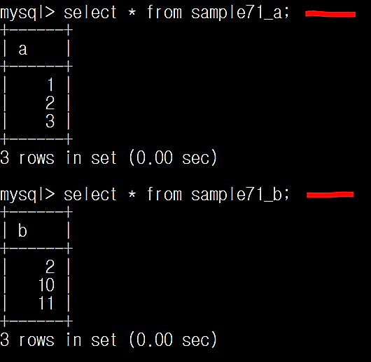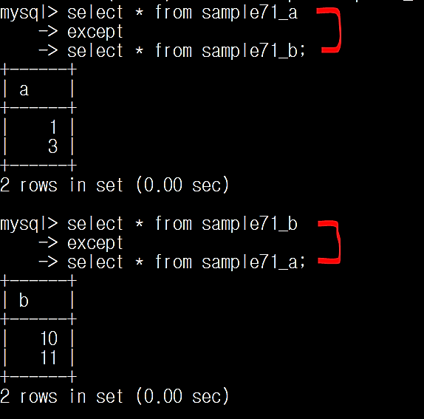

**except 🡪 차집합을 구한다**

**앞 테이블에서 뒤 테이블 교집합을 뺀 결과를 보인다**

**그래서 순서에 따라 결과가 바뀐다**